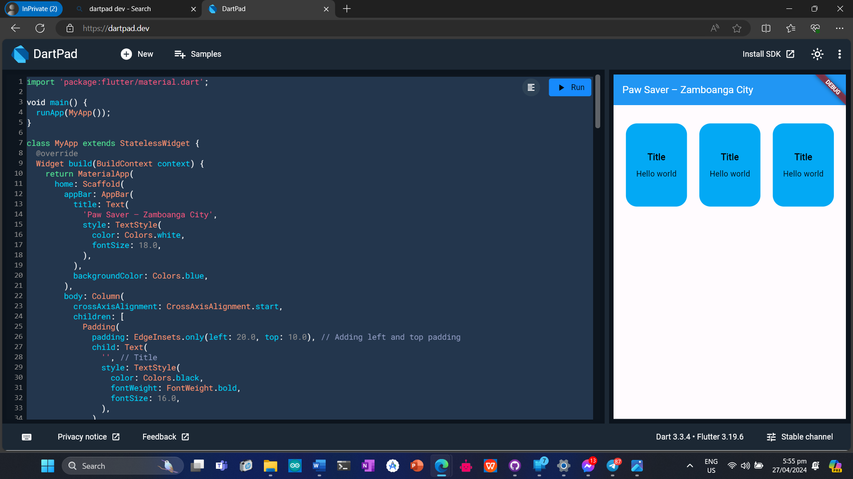

import 'package:flutter/material.dart';

void main() {

runApp(MyApp());

}

class MyApp extends StatelessWidget {

@override

Widget build(BuildContext context) {

return MaterialApp(

home: Scaffold(

appBar: AppBar(

title: Text(

'Paw Saver – Zamboanga City',

style: TextStyle(

color: Colors.white,

fontSize: 18.0,

),

),

backgroundColor: Colors.blue,

),

body: Column(

crossAxisAlignment: CrossAxisAlignment.start,

children: [

Padding(

padding: EdgeInsets.only(left: 20.0, top: 10.0), // Adding left and top padding

child: Text(

'', // Title

style: TextStyle(

color: Colors.black,

fontWeight: FontWeight.bold,

fontSize: 16.0,

),

),

),

Row(

mainAxisAlignment: MainAxisAlignment.spaceEvenly,

children: [

ClipRRect(

borderRadius: BorderRadius.circular(20.0), // Adding border radius

child: Container(

width: 110,

height: 150,

color: Colors.lightBlue, // Change color to sky blue

child: Column(

mainAxisAlignment: MainAxisAlignment.center,

children: [

Text(

'Title',

style: TextStyle(

color: Colors.black,

fontWeight: FontWeight.bold,

fontSize: 16.0,

),

),

SizedBox(height: 8.0),

Text(

'Hello world',

style: TextStyle(

color: Colors.black,

fontSize: 14.0,

),

),

],

),

),

),

ClipRRect(

borderRadius: BorderRadius.circular(20.0), // Adding border radius

child: Container(

width: 110,

height: 150,

color: Colors.lightBlue, // Change color to sky blue

child: Column(

mainAxisAlignment: MainAxisAlignment.center,

children: [

Text(

'Title',

style: TextStyle(

color: Colors.black,

fontWeight: FontWeight.bold,

fontSize: 16.0,

),

),

SizedBox(height: 8.0),

Text(

'Hello world',

style: TextStyle(

color: Colors.black,

fontSize: 14.0,

),

),

],

),

),

),

ClipRRect(

borderRadius: BorderRadius.circular(20.0), // Adding border radius

child: Container(

width: 110,

height: 150,

color: Colors.lightBlue, // Change color to sky

child: Column(

mainAxisAlignment: MainAxisAlignment.center,

children: [

Text(

'Title',

style: TextStyle(

color: Colors.black,

fontWeight: FontWeight.bold,

fontSize: 16.0,

),

),

SizedBox(height: 8.0),

Text(

'Hello world',

style: TextStyle(

color: Colors.black,

fontSize: 14.0,

),

),

],

),

),

),

],

),

],

),

),

);

}

}